CSA1413
COMPILER DESIGN
Name: Haresh Kumar N L
Reg No: 192425009
Count Identifiers

Aim:
To write a LEX program to read a C source program from the a.c file and count the number of identifiers, ignoring keywords, constants, comments, whitespace, and special symbols.

Algorithm:
- Start the program.
- Include the required header files and initialize the identifier count to zero.
- Define rules to recognize and ignore C keywords, constants, comments, whitespace, and special symbols.
- Identify valid identifiers using a regular expression.
- Increment the identifier count for each identifier found.
- Open the a.c file and perform lexical analysis using yylex().
- Display the total number of identifiers.
- Close the file and stop the program.

Pseudocode:
BEGIN
Initialize identifier_count = 0
Open a.c file
IF file opening fails THEN
Print error message
EXIT
END IF
WHILE input remains DO
IF token is a keyword THEN
Ignore token
ELSE IF token is an identifier THEN
Increment identifier_count
ELSE
Ignore token
END IF
END WHILE
Print identifier_count
Close the file
END

Code:
%{
#include <stdio.h>
int identifier_count = 0;
%}
%option noyywrap
%%
"int"|"float"|"char"|"double"|"void"|"if"|"else"|"while"|"for"|"return"|"main"|"break"|"continue"|"do"|"switch"|"case"|"default"|"long"|"short"|"const"|"static"|"unsigned"|"signed"|"sizeof"
;
"//".* ;
"/*"([^*]|\*+[^*/])*\*+"/" ;
[0-9]+ ;
[A-Za-z_][A-Za-z0-9_]* { identifier_count++; }
[ \t\n]+ ;
. ;
%%
int main(void)
{
extern FILE *yyin;
yyin = fopen("a.c", "r");
if (yyin == NULL)
{
printf("Error opening a.c file!\n");
return 1;
}
yylex();
printf("Total number of identifiers: %d\n", identifier_count);
fclose(yyin);
return 0;
}

Input:
int main()
{
int a, b;
a = 10;
b = a + 5;
return 0;}

Output:
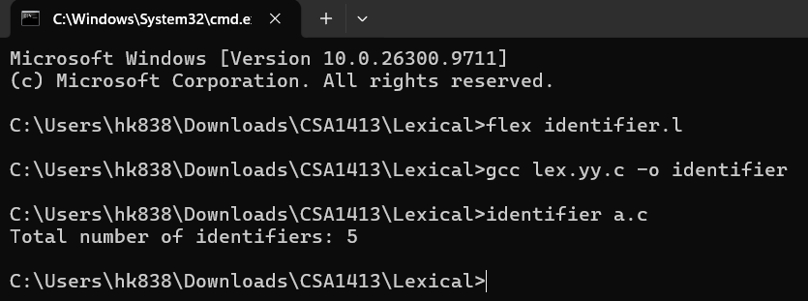

Result:
Thus, the LEX program to count identifiers in the given C source file while ignoring keywords, constants, comments, whitespace, and special symbols was executed successfully.

